
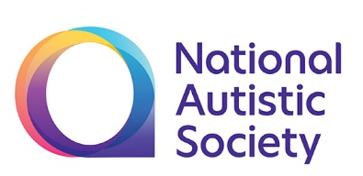
Building Confidence - Identifying and Supporting Additional Needs Workshop
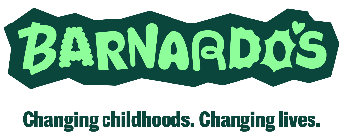
*Dictates mandatory fields. If fields are not completed, your form will be returned
NAS is a non-medical service and does not provide a diagnostic assessment for autism or mental health services.
Receiving support from the NAS does not affect your entitlement to other services.

Parent(s) Details (Main Contact 1st):
*First Name | *Preferred Name |  | *Surname
*Address
Postcode:
Contact details:
*Email:
*Mobile: |  | Phone:

*Name of School:

Child’s Details:
*First Name and Preferred Name | *Surname | *Gender at Birth and  Now known as if different | *DoB | *NHS No. (no spaces) | Ethnicity
1.
2.
3.
4.

Please tell us your reasons for attending this course

*GP Details of Child(ren)
GP Name:
GP Practice Name and Address:

Please tell us about any diagnosis you have or suspect

Special requirements:
Language spoken at home:

Please write any other special requirements here e.g. Interpreter needed:

Other agencies the family is currently receiving support from:  Child in Need Team  Children with Disabilities Team  Child Protection Team | Targeted Youth Support  Family Centres  Other agencies that may be relevant:
CONSENT: I consent to the processing of information as detailed on this form.
This data will be kept securely for the purpose of sharing information about our services that may be of interest/benefit to you. You can choose how we keep in touch with you. It helps us if you can select as many as possible of the options below. A telephone contact can be particularly helpful as it enables us to carry out telephone assessments and arrange appointments when needed. A Post or Email consent enables us to send information to you.
Please confirm if we may contact you by the following methods (please tick to confirm):
Email: Yes □ No □ Post: Yes □ No □ Telephone: Yes □ No □ Text: Yes □ No □
- Please tick if you are happy to receive information about events and services that may be of benefit/interest via email.
Sharing Information: If you are receiving a service from us, we may ask you to consent to information about you and/or your child being shared with other professionals or organisations to help provide you with support, where appropriate, either now or in the future. We will ask you at the time if such a referral is deemed appropriate. We will not share information without your consent except where disclosure is necessary for safeguarding purposes or as required by law.
Signed: _______________________________________________ Date: ___________________
Name: ________________________________________________

Please return to the Family Support Team:  Email:  surrey.familysupport@nas.org.uk | Post:  NAS Surrey Family Support  Surrey Resource Centre  The Old Mill,  14 High St,  Godalming,  GU7 1ED

