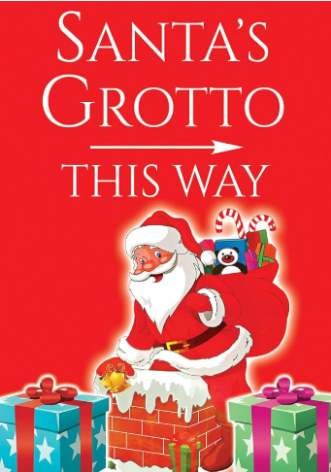

Come and join us for a story with Father Christmas and his elves! Enjoy a snack and Christmas crafts with your friends while you wait.

Book your places here!
Friends of HTPD proudly present

